火炬统计 PDF 辅助上传插件使用说明
Torch Statistics PDF Upload Assistant Plugin User Guide

中国的高企每年要进行统计工作。此项工作的一个环节，是销售收入超过2亿元人民币的企业要上传统计表格的PDF扫描文件。但是系统没有提供上传通道，往年都是线下收集这些文件。下图就是统计系统现在的UI界面。
Chinese high-tech enterprises are required to conduct annual statistical reporting. One part of this process involves companies with sales revenue exceeding 200 million RMB uploading PDF scanned copies of their statistical forms. However, the system currently does not provide an upload channel, so these documents have traditionally been collected offline. The image below shows the current user interface of the statistical system.
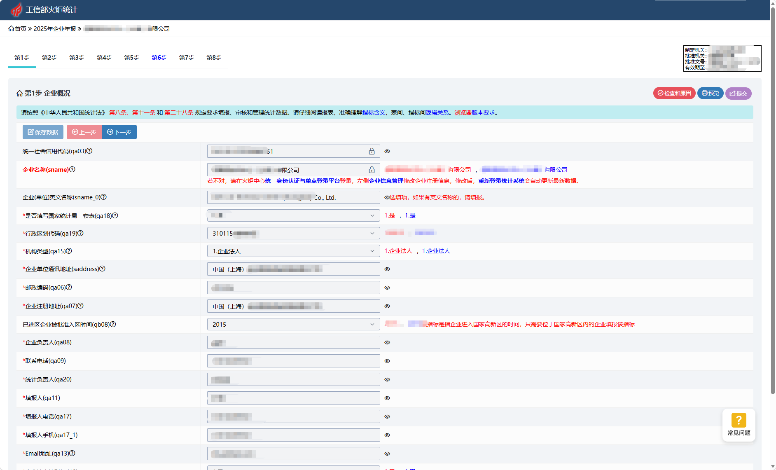
安装本插件后，UI界面上多出三个元素：1、为了插件与后台的交互速度影响主系统的数据流量，在不需要使用插件时，可以关闭插件与后台的交互；2、增加一页参考资料，为统计企业提供参考数据，此页面以后提供静态表格；图示是一个加载了插件的系统UI界面。3、这是最核心的上传按钮。当系统满足①这个账号没有上传过文件②销售收入超过2亿元人民币，按钮显示绿色，处于可用状态。点击按钮弹出文件选取框，加载文件后可上传。
After installing this plugin, three new elements appear in the UI: 1) To reduce data traffic on the main system caused by communication between the plugin and the backend, users can disable this interaction when the plugin is not needed; 2) A reference page has been added to provide statistical data for reporting enterprises, which will later offer static tables; the illustration shows the system's UI with the plugin loaded. 3) This is the core upload button. When both conditions are met—① the account has never uploaded a file before, and ② sales revenue exceeds 200 million RMB—the button turns green and becomes active. Clicking the button opens a file selection dialog; after selecting a file, it can be uploaded.
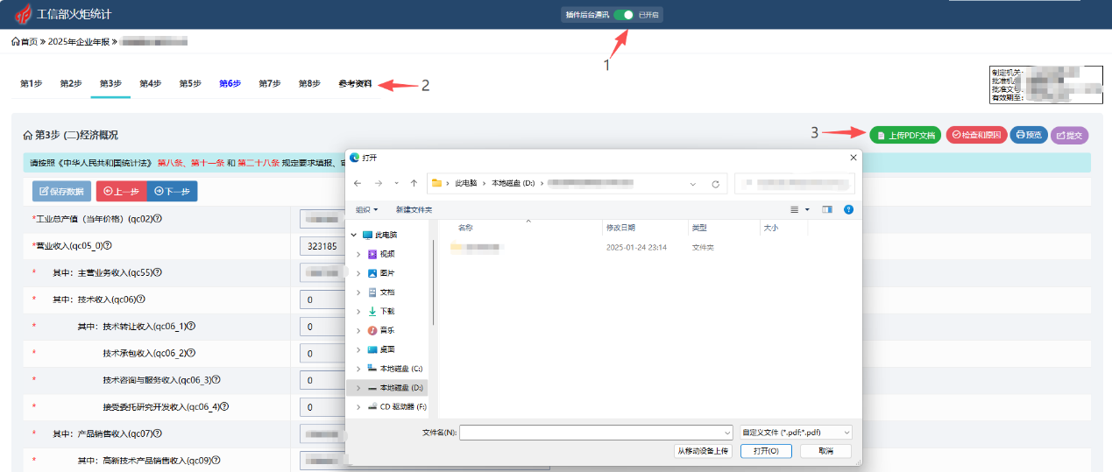
上传成功后，在按钮左侧显示上传文件的名称，也可以删除。此时按钮为灰色，禁用状态。上传数据保存在第三方服务器和数据库。不影响主系统正常功能，不改动主系统数据和数据结构。
After the upload is successful, the name of the uploaded file will be displayed on the left side of the button. The file can also be deleted. At this time, the button will be grayed out and in an unavailable state.
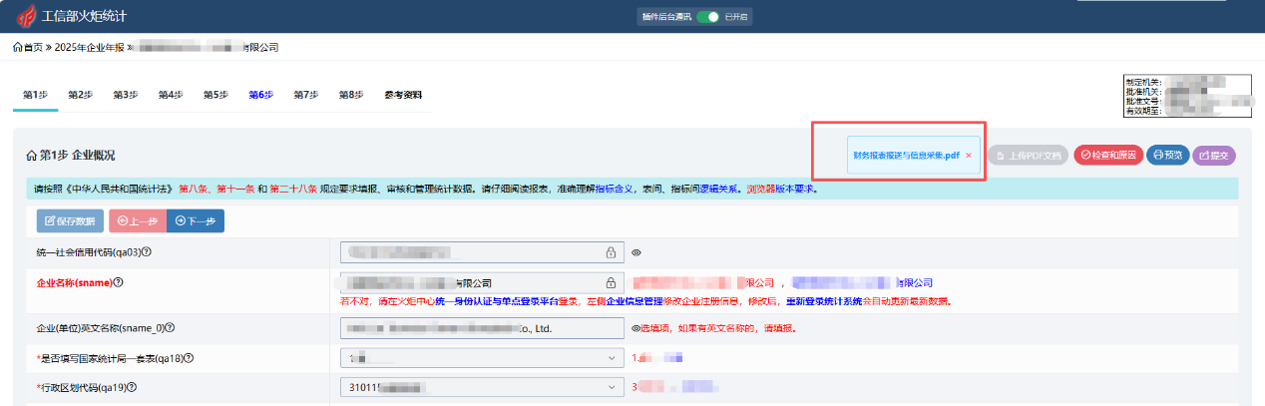

《参考资料》，现在为空白页，今后会提供静态参考数据，不再前端使用JS代码。
"Reference Materials", currently blank, will in the future provide static reference data and will no longer use JS code on the front end.
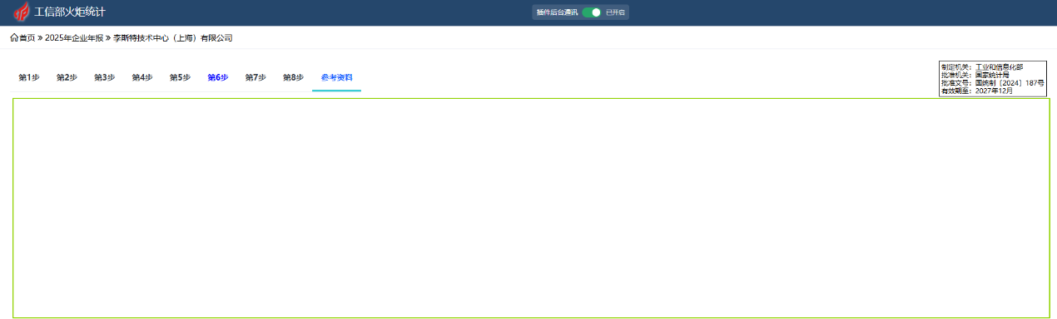
以上是该插件的简单功能介绍。
The above is a brief introduction to the functions of this plugin.

